**Ultra-processed Food Products and Prevalence of Adiposity and Diabetes mellitus: a panel analysis of 76 countries**

Kai Schulze, Jean Adams, Martin White

*MRC Epidemiology Unit, Centre for Diet & Activity Research (CEDAR), University of Cambridge*

**Corresponding author:**

Kai Schulze, PhD Candidate

MRC Epidemiology Unit, University of Cambridge School of Clinical Medicine

Box 285 Institute of Metabolic Science, Cambridge Biomedical Campus, Cambridge CB2 0QQ

+44 (0) 7508714785; ks727@medschl.cam.ac.uk

<http://www.cedar.iph.cam.ac.uk/people/students/kai-schulze/>

**Manuscript word count:**

3474

**Note:**

Tables and figures are appended at the end of the manuscript, online-only supplements in a separate word document.

**Summary**

**Background** Ultra-processed foods have been associated with adverse health outcomes in individual-level studies. Yet, the associations between ultra-processed foods and adiposity and diabetes at the food system level in different regions of the world remain unclear. We aimed to estimate the national level associations globally.

**Methods**

We used country-level statistics from the NCD-RisC, GBD studies, WHO, FAO, World Bank, and Euromonitor to compile a longitudinal panel dataset of 76 countries for the years 2001 – 2016. We used two-level hierarchical linear models with varying intercepts and slopes and fixed-effects regressions with cross-sectionally dependent standard errors as the two main modelling strategies. We estimated the associations for combinations of data processing and analytical choices.

**Findings**

**Interpretation**

**Funding**

**Introduction**In 2016, almost 2 billion adults and 400 million children and adolescents were overweight or obese, over 600 million individuals had diagnosed or undiagnosed diabetes, and the estimated combined global cost exceeds US$3 trillion per year and is predicted to rise substantially in the next decades.1–4 While this “slow-motion disaster”5 now encompasses countries at almost all stages of development, the issue is likely to intensify if current trends continue, given that no country has been able to reverse its obesity rates.6 Suboptimal nutrition and highly- or ultra-processed foods (UPFs) have been implicated as leading risk factors for these related conditions. Previous work has also identified the evolution of commercial food systems towards the delivery of a higher proportion of UPFs as a key driver of this development.7–10 UPFs are those that have undergone multiple physical, biological, and often chemical processes which alter their properties to make them safe, convenient, highly palatable, and very affordable.9,11 Evidence from prospective cohorts has associated these foods with overweight, obesity, and metabolic syndrome.12,13 In the first conducted randomized controlled trial of *ad libitum* UPF versus unprocessed food consumption, participants in the UPF group consumed on average about 500 calories more than participants in the unprocessed group.14 Participants in the UPF group also gained 0·8 kg body weight, while participants in the unprocessed group lost 1·1 kg.

Studies with individual-level data have clear advantages over aggregate data regarding measurement error and various sources of biases. However, individual-level data cannot quantify associations between changes in the overall food system and population-level trends of adiposity and diabetes on a global scale. Furthermore, in regions in which the most rapid transitions of food systems are taking place (mostly low-to-middle income countries), individual-level data is often unavailable or inadequate to quantify the effects of changing diets on health. Prior research has identified changes in sales of UPFs on the country-level and anecdotally associated these with health-outcomes.15,16 However, no systematic study has yet explored the patterns of associations globally. We aimed to estimate the associations between sales of UPF products and the prevalence of adiposity and diabetes mellitus in 76 countries for the years 2001 to 2016.

Methodologically, the biomedical and social sciences currently face the challenge of replication, with an increasing recognition of a failure to reproduce key research findings.17–19 A key observation from the statistical literature is that results can be highly dependent on so-called ‘researcher degrees of freedom’ - the data processing and analytical choices that individual researchers make - even in the absence of selection on statistical significance and in the presence of pre-specified analysis plans.20–23 In a recent study, 29 teams independently pre-specified 29 analyses of the same dataset, yielding 21 unique combinations of covariates and a wide range of results.24 In a similar manner, a replication study identified key data processing steps for which equivalent choices existed to construct alternative datasets and apply the same data analysis as the original article, again producing fundamentally different results.25 If multiple defendable and reasonable combinations of data generating, processing, and analytical choices exist, researchers can increase transparency by displaying the results of combinations of these equally defendable choices in what has been termed a ‘multiverse of statistical results’.25,26

The aim of this study was to describe global levels of UPF consumption, explore bivariate associations between UPFs and adiposity and diabetes mellitus, and estimate the associations between UPF and adiposity and diabetes mellitus prevalence using multiple plausible combinations of outcomes, exposure definitions, covariates, and modelling strategies, to examine a wide range of possible results in the form a ‘multiverse analysis’.

**Methods**

**Data sources**

We identified country-level time-series data from officially published sources available for 40 high-income countries (HICs) and 36 low-to-middle income countries (LMICs) between 2001 and 2016. Age-standardised data for body-mass index (BMI), overweight, and obesity in children, adolescents, and adults was obtained from the NCD Risk Factor Collaboration database (NCD-RisC).27 For adults, adiposity was measured in terms of mean BMI (kg/m2), proportion of the population with a BMI of 25.0 to under 30 (overweight), and proportion of the population with a BMI of over 30 (obese).27 For children and adolescents, the adiposity outcome was measured continuously as mean BMI (kg/m2), as well as in proportions of more than one standard deviation (SD) to two SD above the median (overweight), and more than two SD above the median (obese).27 We used age-standardised sex-specific adult diabetes mellitus prevalence data from NCD-RisC.28

Food data was taken from the Passport Global Market Information Database by Euromonitor International, an independent provider of strategic market research that estimates yearly country-level sales of fresh and packaged foods in retail environments (e.g. supermarkets, grocery shops) and foodservices locations (i.e. full service and take-out restaurants) based on local and regional statistics from various trade sources, national statistics, and company reports.29 We classified statistics on the sales of 42 different food groups into four categories of food processing according to the NOVA classification9: Unprocessed or minimally processed foods (fruits, vegetables, starchy roots, pulses, nuts, rice, fish and seafood, eggs, etc.), processed culinary ingredients (oils and fats, butter, etc.), processed foods (such as frozen yoghurt, processed meat and seafood, cheese, or other diary), and UPFs (breakfast cereals, sweet and savoury snacks, sugar-sweetened beverages, sugar confectionary, ice creams, ready meals, etc.) (see appendix). Thus, the UPF data used in this study was sales data. However, we assumed a strong relationship between the sales and the consumption of UPFs and used the terms sales and consumption of UPFs interchangeably. For the descriptive analyses, the NOVA variables were converted into 100 grams or one litre per day per person with yearly population data from the World Bank.30 In the statistical analyses, we only used NOVA categories one (unprocessed foods) and four (UPFs) in the analysis.

The domestic supply quantity of alcohol per adult age 15 years or older in litres per year was taken from the Global Burden of Disease Study 2016 Covariates.31 Overall dietary energy availability was taken from food balance sheets from the Food and Agriculture Organization Statistical Division as kilocalories (kcal) per person per day.32 As a cross-country indicator for physical activity, we used sex-specific age-standardized prevalence of insufficient physical activity among adults for the year 2010 from the WHO.33,34 GDP per capita was expressed as purchasing power parity and the percentage of population living in urban areas was retrieved from the World Bank.30

Previous studies have found that UPF consumption has plateaued or even decreased in some HICs, while the consumption increased in LMICs in Asia and Latin America.16,35 We planned to explore and estimate associations for HICs and LMICs separately and used the World Bank Income classification of the World Bank development indicators to classify countries. Countries with a gross national income of over US$ 12,476 per capita were classified as high-income and countries with a gross national income of over US$ 1025 and under US$ 12,476 per capita were classified as low-to-middle-income.36 All countries in the sample fell in either of those categories. The complete list of variable definitions and data sources is provided in the appendix. All continuous explanatory variables were z-transformed to a mean of zero and a standard deviation of one.

**Descriptive analysis**

To explore unadjusted longitudinal bivariate associations and identify specific countries with strong associations, we calculated changes of the UPF and outcome variables for each country between 2001 and 2016, with the year 2001 value being the reference value defined as ‘100’. We graphically explored the associations between the country-level change values in bivariate plots and added a quadratic prediction of the outcome variable from a linear regression. We additionally present associations for LMICs and HICs separately.

**Empirical strategy**

The dataset was hierarchically structured and strongly balanced country-level panel data with 16 yearly observations for each country. This type of data structure is a special case of multi-level data in which country-years (lower level-1) data are nested or clustered within countries (higher level-2) over time. To guide the modelling specifications, we performed a series of econometric tests to assess the statistical properties of the dataset. Woolridge’s test37 indicated the presence of autocorrelation within countries, Greene’s test38 suggested heteroscedastic residuals after a fixed-effects regression, findings from Pesaran’s test39 implied cross-sectional dependence of the errors while Frees’40 and Friedman’s tests41 did not, and both the Levin-Lin-Chu and the Im-Pesaran-Shin tests42 suggested the absence of a unit-root of the panel dataset (appendix).

As the first estimation strategy, we performed a fixed-effects regression taking an econometric approach that accounted for heteroscedastic, auto-correlated (or clustered), and cross-sectionally dependent standard errors43, using the following equation, shown in its demeaned form44:

in which the subscript indicates level 2 (country) and denotes level 1 (years). is the outcome that varies between and within countries and is the country-mean of the outcome. is a covariate that varies between and within countries, is the country-mean of that variable, and is the error on level 1 and its mean. By subtracting the country-means, this approach models only the variation within the countries during the study period, and thus represents the ‘within’ coefficient estimate for the variables of interest.45 This is a conservative strategy that minimizes the risk of bias from unobserved confounding between countries, but it excludes time-invariant variables from the estimation, as well as all the variation that exists between the countries in the dataset.45,46 However, the bigger share of the variation in the outcomes and independent variables in our dataset was between countries - potentially relevant information that the fixed-effects approach by design does not consider. To use both within- and between-variation we used a second modelling strategy, a two-level hierarchical linear mixed model which allows for both intercepts and slopes to vary across groups.47,48 We specified the standard errors to account for autocorrelation and heteroscedasticity and used the following equation:

where is the varying intercept of the value of *t* assigned to the country *,* is the varying slope (or coefficient) of covariate for country , and is the country-specific error term. There could be a lag period between changes in UPFs at the food system level and changes in the outcomes because population-level adiposity in a given year is not only affected by the food that was sold and consumed in that specific year, but also of the foods that were consumed in the previous years. Lagged dependent variables would have reduced the observations available for analysis substantially; to be able to take the lag periods into account, we created additional UPF exposure variables with moving averages.49,50 The first variable contained the two-year moving average values of the years *t* and *t-1*, and the second variable included the three-year moving average value of the years and *t, t-1*, and *t-2*, and so on. Since the lag period between changes in the food system and type two diabetes onset are expected to be longer we created an additional four-year moving average. For those years at the start of the period for which no previous years were available we used the maximum number of previous years available.

We specified four types of models for the analysis of adiposity, by first estimating the unadjusted associations and then adding confounders: the first model included only the UPF exposure; to account for the possibility of confounding by unprocessed foods, sex-specific insufficient physical inactivity, or income model two included these variables as covariates; model three additionally adjusted for alcohol consumption (not in children and adolescent populations) and total energy intake; and model four additionally adjusted for the proportion of the population living in urban areas. We did not include or exclude variables based on this approach. For the analysis of diabetes mellitus, we additionally included smoking in model three. The summary of all combinations of the model dimensions are shown in Table 1. The final dataset included all countries for which food exposure data was available, and there were no missing values except for insufficient physical activity for three countries (3·9%); we imputed those values to the median value of the country-group (LMIC or HIC) that the country belonged to. We analysed the dataset without those three countries with missing values, tested the differences of the estimates, and found no substantial difference in the results (appendix).

Although we attempted to identify the best available data for each variable, noisy measurements and measurement errors in the data were to be expected due to the aggregate nature of the data. Given this and the implications from the . In this *P*-values and 95% confidence intervals 95% confidence intervals were calculated for the relative risk estimates in the dose-response and summary meta-analyses. p-values were reported for the Q-test, Egger’s test, Begg’s test, meta-regression, and tests of non-linearity. We recognise that the choice of any particular threshold to determine statistical significance is arbitrary40,41 . To guide interpretation, however, we interpret p-values ≤ 0.005 as strong evidence40,42, p-values > 0.005 & ≤ 0.05 as moderate evidence, p-values > 0.05 and ≤ 0.1 as weak evidence, and p-values > 0.1 as no evidence against the null-hypothesis. Given the noisy measureme Our goal is to report general trends and patterns in associations and uncertainty rather than in All analyses were performed in Stata, version 15.1 (StataCorp LLC, College Station, Texas, USA**).** The full extracted data, the dataset for the meta-analysis, and the Stata code for all analyses are available at https://github.com/kai-schulze/upf_slrma. Instead of defining significance thresholds, we treat p-values as continuous expression of uncertainty and report exact p-values for hypothesis testing. The analysis protocol, Stata and R-codes, as well as sample data for the years 2001 and 2016 can be found on Github (link). Due to data licensing restriction we cannot make the full dataset available; please contact the first author for replication requests.

|  |  |  |  |
| --- | --- | --- | --- |
| Dimension | Specification | Number of specifications | |
| Outcome | Diabetes | | 1 |
| Population | Adults | | 1 |
| Sex | Female  Male | | 2 |
| Exposure averages | Yearly  Two-year average  Three-year average  Four-year average | | 4 |
| Number of models | M1: Ultra-processed foods  M2: M1 + unprocessed foods, insufficient physical activity, GDP  M3: M2 + Total energy intake, alcohol consumption, smoking  M4: M3 + proportion of population in urban areas | | 4 |
| Statistical approaches | 1. Fixed effects regression with SE adjusted for heteroscedasticity, autocorrelation, and cross-sectional dependence  2. Two-level hierarchical linear mixed model with varying intercepts and coefficient with SE adjusted for autocorrelation and heteroscedasticity | | 2 |
| Π | Total number of estimates (product): | | 64 |

***Table 1*:** Multiverse model dimensions for adiposity (top) and diabetes (bottom).

|  |  |  |  |
| --- | --- | --- | --- |
| Dimension | Specification | Number of specifications | |
| Outcomes | BMI  Overweight  Obesity | | 3 |
| Population | Adults  Children & adolescents | | 2 |
| Sex | Female  Male | | 2 |
| Exposure averages | Yearly  Two-year average  Three-year average | | 3 |
| Number of models | M1: Ultra-processed foods  M2: M1 + unprocessed foods, insufficient physical activity, GDP  M3: M2 + Total energy intake, alcohol consumption (for adults)  M4: M3 + proportion of population in urban areas | | 4 |
| Statistical approaches | 1. Fixed effects regression with SE adjusted for heteroscedasticity, autocorrelation, and cross-sectional dependence  2. Two-level hierarchical linear mixed model with varying intercepts and coefficient with SE adjusted for autocorrelation and heteroscedasticity | | 2 |
| Π | Total number of estimates (product) | | 288 |

**Role of the funding source**

There was no specific funding source for this study. KS is funded by a PhD studentship of the Medical Research Council UK, KS, MW, and JA had full access to all the data in the study and all authors had final responsibility for the decision to submit for publication.

**Results**

We included data from 76 countries over 16 years, giving 1216 observations in total and representing a population of 5·9 billion individuals in 2016. Table 2 shows descriptive statistics of the country samples in years 2001 and 2016. The prevalence of both adiposity and diabetes increased substantially during the study period for both genders and for adults and children. Compared to girls, obesity prevalence in boys was higher in 2001 and increased more during the study period. Unprocessed food consumption, urban population, GDP per capita, and total available energy grew during the study period, whereas per capita alcohol consumption changed little.

|  |  |  |  |  |
| --- | --- | --- | --- | --- |
|  | 2001 | 2016 | |  |
|  | **Median (IQR)** | **Median (IQR)** | **p-value\*** | |
| Population (n=76 countries) | 5.2 billion | 5.9 billion | |  |
| BMI (adult male) [kgm-1] | 25.8 (24.5-26.4) | 26.8 (25.8-27.5) | | <0.001 |
| BMI (adult female) [kgm-1] | 25.7 (25.0-26.3) | 26.7 (25.3-27.4) | | <0.001 |
| BMI (boys) [kgm-1] | 19.1 (18.6-19.6) | 19.8 (19.4-20.2) | | 0.008 |
| BMI (female) [kgm-1] | 19.2 (18.7-19.9) | 19.6 (19.1-20.2) | | <0.001 |
| Obesity prevalence (males) [%] | 15.3 (10.4-17.3) | 22.1 (17.1-25.0) | | <0.001 |
| Obesity prevalence (females) [%] | 19.0 (15.6-23.7) | 25.2 (20.6-29.7) | | <0.001 |
| Obesity prevalence (boys) [%] | 5.6 (4.2-8.6) | 10.8 (8.6-14.0) | | <0.001 |
| Obesity prevalence (girls) [%] | 4.0 (2.6-6.0) | 7.3 (4.8-10.3) | | <0.001 |
| Diabetes prevalence (male) [%] | 6.5 (5.6-8.0) | 8.4 (7.4-10.0) | | 0.037 |
| Diabetes prevalence (female) [%] | 6.7 (6.1-7.6) | 7.1 (5.9-10.4) | | <0.001 |
| Ultra-Processed Foods [g per capita/d]  Low-to-middle income countries  High-income countries | 405 (249-598)  261 (120-358)  572 (434-669) | 458 (323-632)  335 (189-435)  558 (418-687) | | 0.061 |
| Unprocessed Foods [g per capita/d] | 731 (557-852) | 821 (639-993) | | <0.001 |
| Urban Population [%] | 66 (55-78) | 70 (58-82) | | 0.10 |
| Alcohol consumption [litres per capita] | 9.1 (6.0-12.2) | 9.3 (6.7-11.6) | | 0.87 |
| Total Energy Supply [100 kcal/d] | 3012.1 (2738.0-3327.4) | 3158.1 (2911.7-3417.8) | | 0.020 |
| GDP per capita (PPP) | 9905.0 (6105.0-25265.0) | 22780.0 (13800.0-37825.0) | | <0.001 |

***Table 2*:** Descriptive statistics at 2001 and 2016. *p-value for Wilcoxon-rank sum test of equal medians. N=76 countries in both years.

Globally, absolute intake of UPF consumption in 2016 differed substantially between countries (Figure 1, top panel), with most high-income countries consuming more than 500 g per capita per day. Most of low-to-middle income had consumption levels below that level, except for Chile, Argentina, Saudi-Arabia, and Algeria. Changes in the consumption of UPFs between 2001 and 2016 differed between countries of different levels of development – while the consumption decreased slightly from 572 to 558 grams per day on average in high-income countries, the consumption in low-to-middle income countries increased on average by almost 30% from 261 to 335 grams per day on average. Among the countries with increases of over 50% were China (299%), India (267%), Indonesia (216%), Pakistan (213%), Peru (181%), Thailand (172%), Nigeria (170%), and Chile (150%); the descriptive statistics for each country can be found in the appendix.

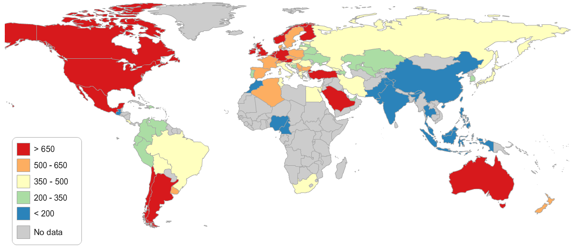

***Figure 1:*** Levels of ultra-processed food consumption in g per capita per day in 2016 (top panel) and changes in ultra-processed food consumption from 2001 to 2016 (bottom panel, in %, 2001=100%).

Plotting the changes of the three different adiposity measures (overweight not shown, see appendix) against the changes in UPF consumption shows similar positive bivariate associations across the different populations and outcomes (Figure 2). Some countries experienced large increases in obesity prevalence, especially in children and adolescents, notably China, India, Nigeria, Pakistan, South Africa, and Thailand. Some of these countries had very low obesity prevalence in 2001 (e.g. 0·3% in Cameroon or 0·4% in India in boys), but some countries had close to sample-average levels of obesity in 2001 (e.g. 3·3% in China or 4·5% in Thailand in boys) but still saw a tripling or quadrupling of the obesity prevalence.

|  |  |  |  |  |
| --- | --- | --- | --- | --- |
|  | **Female** | **Male** | **Girls** | **Boys** |
| **Change in BMI (in %)** |  | | | |
| **Change in Obesity Prevalence (in %)** |
|  | **Change in Ultra-processed Food Consumption (in %)** | | | |

***Figure 2:*** Bivariate association between changes in ultra-processed food consumption and BMI (top row) and obesity prevalence (bottom row). Changes between 2001 and 2016, in %, 2001 = 100. Quadratic predictions from linear regressions between the two change variables as solid lines.

|  |  |  |  |  |  |
| --- | --- | --- | --- | --- | --- |
|  | **Females LMIC\*** | | **Females HICƚ** | **Girls LMIC** | **Girls HIC** |
| **Change in diabetes prevalence (in %) Change in obesity prevalence (in %)** |  | | | | |
| **Females** | **Males** | | **Females LMIC** | **Females HIC** |
|  | | | | |
|  | **Change in Ultra-processed food consumption (in %)** | | | | |

***Figure 3:*** Bivariate association between changes in ultra-processed food consumption and BMI (top row) and obesity prevalence (bottom row). Changes between 2001 and 2016, in %, 2001 = 100. Quadratic predictions from linear regressions between the two change variables as solid lines. *LMIC = Low- and middle-income countries; ꝉHIC= High-income countries.

Figure 3 shows the unadjusted bivariate association between changes in obesity prevalence and UPF consumption separately for LMICs and HICs for both females and girls. The associations are different between LMICs and HICs – while the association is positive for females and girls in LMICs, a flat or even slightly negative association is observed in HICs. The bivariate associations between UPF and diabetes prevalence were similar for females and males, while stratifying the association of female diabetes prevalence by LMICs and HICs did not show a clear differential pattern.

In the multiverse analysis, all 288 coefficient estimates of the association between UPFs and adiposity were positive except nine (Figure 4). We found generally stronger associations between BMI and UPFs than for overweight and obesity, with less uncertainty around the estimates (i.e. most of the p-values<0·001). The size of the coefficients generally increased with length of rolling average of UPFs, and the inclusion of urbanization as a covariate in model four attenuated the association substantially. Coefficients were larger for children and adolescent populations and between the two main estimation approaches the estimated associations of the multilevel-models were generally higher than in the fixed-effects regressions. There was no differential pattern between sexes in the estimates in the adult populations: while the associations for females were stronger in the multilevel model, the association for males was higher in the fixed-effects regressions. However, across all combinations in the multiverse, the associations between UPFs and adiposity were stronger for boys than for girls.

We performed analyses stratified by the two pre-specified levels of country income separately that showed clear differences in the strength and uncertainty of the estimated associations (Figure 5). In LMICs, the coefficients of the association between UPFs and adiposity were large, mostly positive, and with low uncertainty (p-value<0·001) in over 85% of the estimated associations. In high-income countries, the pattern was inverted; coefficients were small, sometimes negative while the uncertainty around the estimates was generally high across the multiverse combinations.

**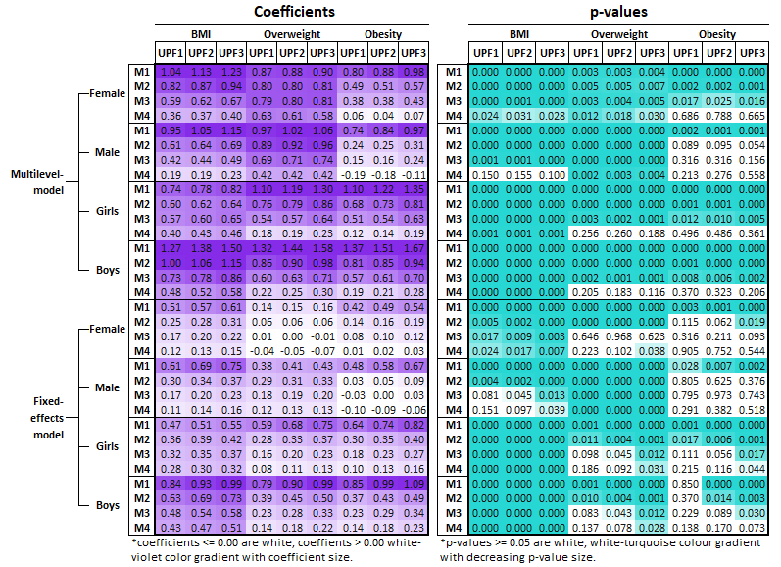*Figure 4:*** Associations between UPFs and adiposity for 76 countries between 2001 and 2016. Left panel: coefficients denote the change in the outcome variables (in SD) for a one SD increase in UPFs. Right panel: p-values for the UPF coefficient estimations. UPF1-3: rolling averages of UPFs. M1: UPFs (unadjusted); M2: M1 + unprocessed foods, insufficient physical activity, GDP per capita (PPP); M3: M2 + total available energy, alcohol consumption; M4: M3 + urbanization.

**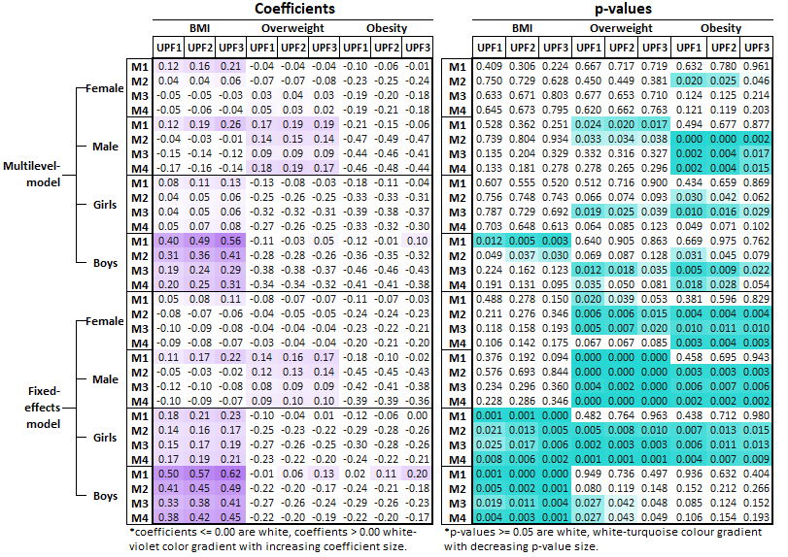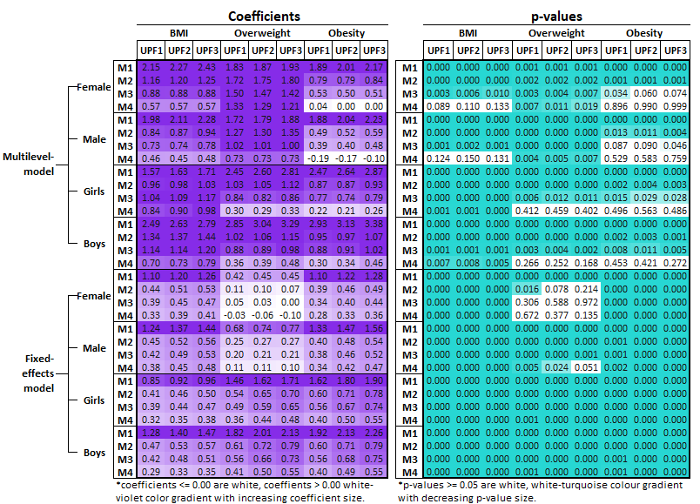*Figure 5:*** Associations between UPFs and adiposity between 2001 and 2016, for LMICs (top panels) and HICs (bottom panels) separately. Left panels: coefficients denote the change in the outcome variables (in SD) for a one SD increase in UPFs. Right panel: p-values for the UPF coefficient estimations. UPF1-3: rolling averages of UPFs. M1: UPFs (unadjusted); M2: M1 + unprocessed foods, insufficient physical activity, GDP per capita (PPP); M3: M2 + total available energy, alcohol consumption; M4: M3 + urbanization.

**Discussion**

**Statement of principal findings**

In this study, we compiled a database of yearly country-level panel data of UPF sales and adiposity and diabetes outcomes for 76 countries between the years 2001 and 2016 and did the most comprehensive analysis of their associations so far. Our findings contribute to the ongoing debate of the role of UPFs and commercial food system in the global adiposity and diabetes crises.7,12,13,51,52 We show that levels of UPFs varied greatly between countries and find large increases in sales of UPFs in LMICs, while sales of UPFs stagnate in many HICs and even slightly decrease in HICs on average. The exploration of unadjusted bivariate associations indicated a generally positive association between changes in UPFs and adiposity, with particularly strong associations in so-called ‘emerging markets’53 such as Chile, China, India, Indonesia, Pakistan, South Africa, or Thailand. In LMICs, adiposity was positively associated with UPFs across almost all combinations of the ‘multiverse’ analysis with low p-values. In HICs, a large variation in coefficients was observed, with p-values being high in many cases, although associations were negative sometimes as well.

**Interpretation and comparisons with other studies**

Several hypotheses can be put forward to explain our findings that greater consumption of UPFs was associated with adiposity on the country-level. Previous studies have also found that the sales of UPFs have plateaued or even decreased in high-income countries and increased in LMICs in Asia and Latin America.16,35

**Strengths and weaknesses of the study**

Omitted variable bias

Our study has limitations. Its ecological nature means that the analysis is based on aggregate-level data does not allow inferences to be made at an individual level. Additionally

**Strengths and weaknesses in relation to other studies, discussing particularly any differences in results**

**Meaning of the study: possible mechanisms and implications for clinicians or policymakers**

**Unanswered questions and future research**

COLLECTION OF NOTES FOR DISCUSSION:

So key points for me are really what can you conclude from ecological analyses?! Esp given findings seem to contradict those from your other studies – which I think are mostly based on data from HIC; and are stronger study designs?

How valid do you think the data is (esp on UPF)? Does validity vary across countries and could that be a source of bias? Does it vary by time – eg better case finding of esp diabetes more recently?

How generalizable are the findings? Looks to me like ~85% of world pop included. But worth stating that. Also, biases in which countries did and didn’t get included?

What’s your explanation for the urbanisation effect? Esp given phys ac & total energy is already accounted for? Could it be a proxy for data quality?

As you’ve used weight of UPF (not energy) do you think you need to go into the whole SSB thing here too? Would a sensible sensitivity be to separate out SSB from other UPF? Is that feasible?

Is the difference in effect in HIC vs LMIC evidence of a threshold effect? That isn’t obvious from fig 2, but that might be because the metrics are relative not absolute. Or is it evidence of reverse causality – once you’re obese/diabetic you stop eating/drinking this stuff – particularly if those outcomes are identified as unhealthy in your culture (which I think is less the case in LIC)?

Methods:

Previous evidence has shown that sales of UPFs have stagnated in HICs and have increased substantially in LMICs.

We tried to include as many confounders at the national level as possible

* Comment Martin ethnicity specific cutoffs of BMI (what did they do about it? Maybe it is already included in the data that I have?)
* Confidence intervals for each estimate an be added as only material
* Sensitivity analysis by leaving out GDP in the stratified analysis
* Associations for the variables unprocessed foods & urbanization rate
* Put the country-values for UPF into the appendix
* Find a way to display the estimates for each country, but from the models to see how the difference between unadjusted and adjusted associations is

1. World Health Organization (WHO). Obesity and overweight key facts. 2018. http://www.who.int/en/news-room/fact-sheets/detail/obesity-and-overweight. Accessed November 7, 2018.

2. GBD 2016 Disease and Injury Incidence and Prevalence Collaborators. Global, regional, and national incidence, prevalence, and years lived with disability for 328 diseases and injuries for 195 countries, 1990–2016: a systematic analysis for the Global Burden of Disease Study 2016. *Lancet*. 2017;390(10100):1211-1259. doi:10.1016/S0140-6736(17)32154-2

3. Zhang P, Gregg E. Global economic burden of diabetes and its implications. *lancet Diabetes Endocrinol*. 2017;5(6):404-405. doi:10.1016/S2213-8587(17)30100-6

4. McKinsey Global Institute. *Overcoming Obesity: An Initial Economic Analysis*.; 2014. https://www.mckinsey.com/~/media/mckinsey/business functions/economic studies temp/our insights/how the world could better fight obesity/mgi_overcoming_obesity_full_report.ashx. Accessed March 16, 2019.

5. Chan DM. Obesity and diabetes: the slow-motion disaster Keynote address at the 47th meeting of the National Academy of Medicine. *WHO*. 2016. http://www.who.int/dg/speeches/2016/obesity-diabetes-disaster/en/. Accessed November 7, 2018.

6. Ng M, Fleming T, Robinson M, et al. Global, regional, and national prevalence of overweight and obesity in children and adults during 1980–2013: a systematic analysis for the Global Burden of Disease Study 2013. *Lancet*. 2014;384(9945):766-781. doi:10.1016/S0140-6736(14)60460-8

7. Monteiro CA, Moubarac J-C, Cannon G, Ng SW, Popkin B. Ultra-processed products are becoming dominant in the global food system. *Obes Rev*. 2013;14 Suppl 2:21-28. doi:10.1111/obr.12107

8. Moodie R, Stuckler D, Monteiro C, et al. Profits and pandemics: prevention of harmful effects of tobacco, alcohol, and ultra-processed food and drink industries. *Lancet*. 2013;381(9867):670-679. doi:10.1016/S0140-6736(12)62089-3

9. Monteiro CA, Cannon G, Moubarac J-C, Levy RB, Louzada MLC, Jaime PC. The UN Decade of Nutrition, the NOVA food classification and the trouble with ultra-processing. *Public Health Nutr*. March 2017:1-13. doi:10.1017/S1368980017000234

10. Stuckler D, McKee M, Ebrahim S, Basu S. Manufacturing epidemics: the role of global producers in increased consumption of unhealthy commodities including processed foods, alcohol, and tobacco. *PLoS Med*. 2012;9(6):e1001235. doi:10.1371/journal.pmed.1001235

11. Fiolet T, Srour B, Sellem L, et al. Consumption of ultra-processed foods and cancer risk: results from NutriNet-Santé prospective cohort. *BMJ*. 2018;360:322. doi:10.1136/bmj.k322

12. Mendonça R de D, Pimenta AM, Gea A, et al. Ultraprocessed food consumption and risk of overweight and obesity: the University of Navarra Follow-Up (SUN) cohort study. *Am J Clin Nutr*. 2016;104(5):1433-1440. doi:10.3945/ajcn.116.135004

13. Tavares LF, Fonseca SC, Garcia Rosa ML, Yokoo EM. Relationship between ultra-processed foods and metabolic syndrome in adolescents from a Brazilian Family Doctor Program. *Public Health Nutr*. 2012;15(1):82-87. doi:10.1017/S1368980011001571

14. Hall KD. Ultra-processed diets cause excess calorie intake and weight gain: A one-month inpatient randomized controlled trial of ad libitum food intake. doi:10.31232/OSF.IO/W3ZH2

15. WHO. Ultra-processed foods are driving the obesity epidemic in Latin America, says new PAHO/WHO report. September 2015. http://www.paho.org/hq/index.php?option=com_content&view=article&id=11180:ultra-processed-foods&Itemid=1926&lang=en. Accessed January 13, 2016.

16. Baker P, Kay A, Walls H. Trade and investment liberalization and Asia’s noncommunicable disease epidemic: a synthesis of data and existing literature. *Global Health*. 2014;10(1):66. doi:10.1186/s12992-014-0066-8

17. Open Science Collaboration OS. Estimating the reproducibility of psychological science. *Science*. 2015;349(6251):aac4716. doi:10.1126/science.aac4716

18. Camerer CF, Dreber A, Forsell E, et al. Evaluating replicability of laboratory experiments in economics. *Science*. 2016;351(6280):1433-1436. doi:10.1126/science.aaf0918

19. Kaiser J. Plan to replicate 50 high-impact cancer papers shrinks to just 18. *Science (80- )*. July 2018. doi:10.1126/science.aau9619

20. Simmons JP, Nelson LD, Simonsohn U. False-Positive Psychology. *Psychol Sci*. 2011;22(11):1359-1366. doi:10.1177/0956797611417632

21. Wicherts JM, Veldkamp CLS, Augusteijn HEM, Bakker M, van Aert RCM, van Assen MALM. Degrees of Freedom in Planning, Running, Analyzing, and Reporting Psychological Studies: A Checklist to Avoid p-Hacking. *Front Psychol*. 2016;7:1832. doi:10.3389/fpsyg.2016.01832

22. Gelman A, Loken E. *The Garden of Forking Paths: Why Multiple Comparisons Can Be a Problem, Even When There Is No “Fishing Expedition” or “p-Hacking” and the Research Hypothesis Was Posited Ahead of Time*.; 2013. http://www.stat.columbia.edu/~gelman/research/unpublished/p_hacking.pdf. Accessed November 7, 2018.

23. Gelman A, Loken E. The Statistical Crisis in Science. *Am Sci*. 2014;102(6):460. doi:10.1511/2014.111.460

24. Silberzahn R, Uhlmann EL, Martin DP, et al. Many Analysts, One Data Set: Making Transparent How Variations in Analytic Choices Affect Results. *Adv Methods Pract Psychol Sci*. 2018;1(3):337-356. doi:10.1177/2515245917747646

25. Steegen S, Tuerlinckx F, Gelman A, Vanpaemel W. Increasing Transparency Through a Multiverse Analysis. *Perspect Psychol Sci*. 2016;11(5):702-712. doi:10.1177/1745691616658637

26. Cox GE, Hemmer P, Aue WR, Criss AH. Information and processes underlying semantic and episodic memory across tasks, items, and individuals. *J Exp Psychol Gen*. 2018;147(4):545-590. doi:10.1037/xge0000407

27. NCD Risk Factor Collaboration (NCD-RisC) L, Abdeen ZA, Hamid ZA, et al. Worldwide trends in body-mass index, underweight, overweight, and obesity from 1975 to 2016: a pooled analysis of 2416 population-based measurement studies in 128·9 million children, adolescents, and adults. *Lancet*. 2017;390(10113):2627-2642. doi:10.1016/S0140-6736(17)32129-3

28. NCD Risk Factor Collaboration (NCD-RisC) NRFC. Worldwide trends in diabetes since 1980: a pooled analysis of 751 population-based studies with 4.4 million participants. *Lancet (London, England)*. 2016;387(10027):1513-1530. doi:10.1016/S0140-6736(16)00618-8

29. Euromonitor International. Passport Global Market Information Database. Passport Global Market Information Database. https://www.portal.euromonitor.com/portal/magazine/homemain. Accessed October 30, 2018.

30. World Bank. World Development Indicators. 2018. https://data.worldbank.org/. Accessed May 19, 2016.

31. Global Burden of Disease Collaborative Network. Global Burden of Disease Study 2016 (GBD 2016) Covariates 1980-2016. 2017. http://ghdx.healthdata.org/record/global-burden-disease-study-2016-gbd-2016-covariates-1980-2016. Accessed June 20, 2018.

32. Food and Agriculture Organization of the United Nations (FAO). FAOSTAT. Statistical database. FAO. http://www.fao.org/faostat/en/#data. Published 2018. Accessed February 7, 2018.

33. World Health Organization (WHO). Prevalence of insufficient physical activity among adults - Data by country. *WHO*. http://apps.who.int/gho/data/view.main.2463. Accessed February 7, 2018.

34. Global Health Observatory. Prevalence of insufficient physical activity among adults aged 18+ years - Indicator Registry. *WHO*. 2017. http://apps.who.int/gho/data/node.wrapper.imr?x-id=2381. Accessed December 20, 2018.

35. PAHO. *Fact Sheet: Consumption of Ultra-Processed Food and Drink Products in Latin America: Trends, Impact on Obesity, and Policy Implications*. Washington, D.C., USA.; 2014. http://wphna.org/wp-content/uploads/2014/09/2014-09_PAHO_fact_sheet_on_UPPS_and_obesity.pdf. Accessed July 5, 2018.

36. World Bank. New country classifications by income level: 2016-2017. World Development Indicators database. https://blogs.worldbank.org/opendata/new-country-classifications-2016. Published 2016. Accessed June 20, 2018.

37. Wooldridge JM. *Econometric Analysis of Cross Section and Panel Data*. MIT Press; 2010. https://books.google.com/books?hl=en&lr=&id=yov6AQAAQBAJ&pgis=1. Accessed April 15, 2015.

38. Greene WH. *ECONOMETRIC ANALYSIS*. Upper Saddle River, NJ: Prentice-Hall; 2000. https://spu.fem.uniag.sk/cvicenia/ksov/obtulovic/Manaž. štatistika a ekonometria/EconometricsGREENE.pdf. Accessed November 8, 2018.

39. Pesaran, M.H. ‘General Diagnostic Tests for Cross Section Dependence in Panels.’ *Cambridge Work Pap Econ*. 2004. https://ideas.repec.org/p/cam/camdae/0435.html. Accessed November 8, 2018.

40. Frees EW. *Longitudinal and Panel Data : Analysis and Applications in the Social Sciences*. Cambridge University Press; 2004. https://books.google.de/books/about/Longitudinal_and_Panel_Data.html?id=seU3qmlejZIC&redir_esc=y. Accessed November 8, 2018.

41. Friedman M. *The Use of Ranks to Avoid the Assumption of Normality Implicit in the Analysis of Variance*. Vol 32.; 1937.

42. Nell C, Zimmermann S. *Summary Based on Chapter 12 of Baltagi : Panel Unit Root Tests*.; 2011.

43. Hoechle D. Robust standard errors for panel regressions with cross-sectional dependence. *Stata J*. 2007;7(3):281-312. doi:The Stata Journal

44. Schunck R, Perales F, Schunck R, Perales F. Within- and between-cluster effects in generalized linear mixed models: A discussion of approaches and the xthybrid command. *Stata J*. 2017;17(1):89-115. https://econpapers.repec.org/article/tsjstataj/v_3a17_3ay_3a2017_3ai_3a1_3ap_3a89-115.htm. Accessed November 8, 2018.

45. Brüderl J, Ludwig V. Fixed-effects panel regression. January 2015:327-356. https://www.researchgate.net/publication/288254393_Fixed-effects_panel_regression. Accessed February 19, 2016.

46. Dieleman JL, Templin T, Dalby AR. Random-Effects, Fixed-Effects and the within-between Specification for Clustered Data in Observational Health Studies: A Simulation Study. 2014. doi:10.1371/journal.pone.0110257

47. Gelman A, Hill J. *Data Analysis Using Regression and Multilevel/Hierarchical Models*. Cambridge: Cambridge University Press; 2012. doi:10.1017/CBO9780511790942

48. Cohen J, Cohen J. *Applied Multiple Regression/Correlation Analysis for the Behavioral Sciences*. L. Erlbaum Associates; 2003.

49. Pesaran MH. *Time Series and Panel Data Econometrics*. Oxford University Press; 2015. doi:10.1093/acprof:oso/9780198736912.001.0001

50. Davis R, Resnick S. Limit Theory for the Sample Covariance and Correlation Functions of Moving Averages. *Ann Stat*. 14:533-558. doi:10.2307/2241234

51. Lean MEJ, Astrup A, Roberts SB. Making progress on the global crisis of obesity and weight management. *BMJ*. 2018;361:k2538. doi:10.1136/bmj.k2538

52. OpenAccessGovernment.org. Diabetes: The fastest growing health crisis of our time. https://www.openaccessgovernment.org/diabetes-health-crisis-diabetes-uk/44857/. Published 2018. Accessed March 16, 2019.

53. Morgan Stanley Capital International. MSCI EMERGING MARKETS INDEX. *MSCI Emerg Mark Index*. 2015:30-31. https://www.msci.com/documents/10199/c0db0a48-01f2-4ba9-ad01-226fd5678111. Accessed March 16, 2019.